How to run Azure regression against OS of latest version

Table of Contents
1 Prepare Base VHD 3
1.1 Download the VHD or ISO 3
1.2 Create a virtual machine with Hyper-V manager 3
1.3 Install Visual studio on VM 5
2 Prepare Azure Image 6
2.1 Prepare a Windows VHD or VHDX to upload to Azure 6
2.2 Convert the virtual disk to a fixed size VHD 6
2.2.1 Use Hyper-V Manager to convert the disk 6
2.2.2 Use Hyper-V Manager to resize the disk 6
2.3 Upload the VHD and create azure image 6
3 Modify the .csv file 9
4 Run Azure Regression job with pipeline 10

Prepare Base VHD

Download the VHD or ISO
Download VHD file from \\pet-storage-04\VHDLib\20H2

Create a virtual machine with Hyper-V manager
- Open Hyper-V Manager by either pressing the Window's key and typing "Hyper-V Manager" or by finding Hyper-V Manager in your applications.
- In Hyper-V Manager, click Action > New > Virtual Machine to bring up the New Virtual Machine Wizard.
- Review the “Before You Begin” content and click Next.
- In the Name text box, type a string for the virtual machine name.
Note: This is the name which is used by Hyper-V to identify the virtual machine, not the computer name given to the guest operating system that will be deployed inside the virtual machine.
- Choose a location where the virtual machine files will be stored such as c:\virtualmachine. You can also accept the default location. Click Next when done.
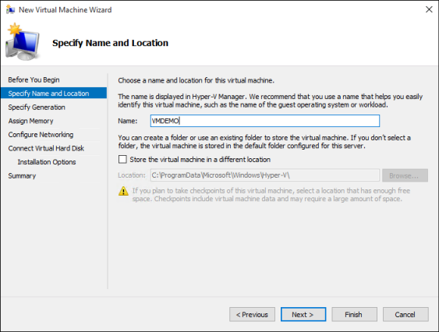
- Select a generation for the virtual machine and click Next.
- Select 8192 MB for the Startup Memory value and leave Use Dynamic Memory selected. Click the Next button.
- On the Configure Networking wizard, select a virtual switch (it can connect to the Internet) for the virtual machine and click Next. For more information, see Create a Virtual Switch.
- Configure Virtual Hard Disk
  - If install OS with ISO file, give the virtual hard drive a name, select a location or keep the default, and finally specify a size. Click Next when ready. On the Installation Options wizard, select Install an operating system from a bootable image file and then select an operating system .iso file. Click Next once completed.
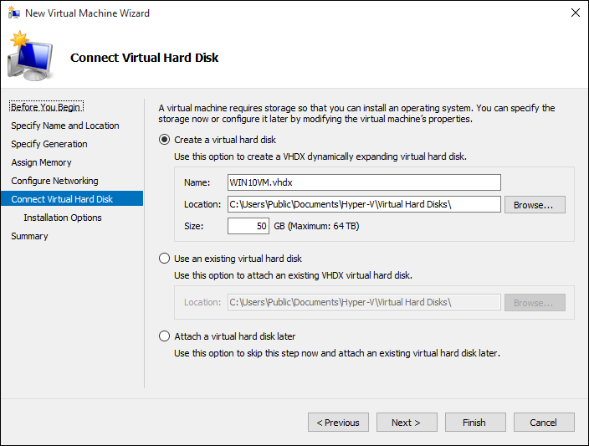
  - If use VHD, select “use an existing virtual hard disk” and give the location, Click Next when ready
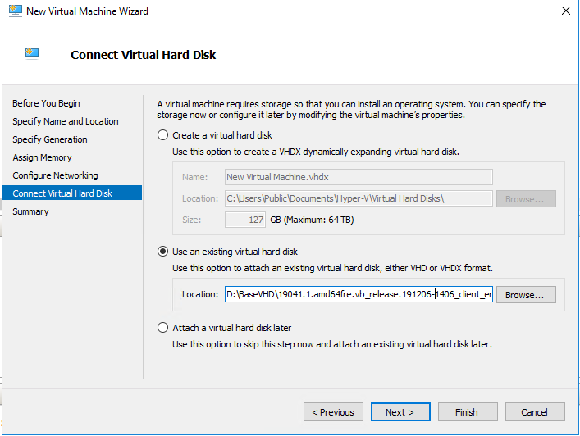
- Review the virtual machine details and click Finish to complete the virtual machine creation.
- Start the VM
- Using CTRL+SHIFT+F3 to enter audit mode on the VM

Install Visual studio on VM
Download visual studio 2019 from link, and install it with as following command
<vs_enterprise.exe> ^
--add Microsoft.NetCore.Component.SDK ^
--add Microsoft.VisualStudio.Component.Roslyn.Compiler ^
--add Microsoft.VisualStudio.Component.VC.Tools.x86.x64 ^
--add Microsoft.VisualStudio.Component.VC.CLI.Support ^
--add Microsoft.VisualStudio.Component.VC.Redist.14.Latest ^
--add Microsoft.VisualStudio.Component.VC.CoreIde ^
--add Microsoft.VisualStudio.Component.Windows10SDK.19041 ^
--add Microsoft.VisualStudio.Component.TestTools.WebLoadTest ^
--passive --norestart

Prepare Azure Image

Prepare a Windows VHD or VHDX to upload to Azure
Details refer to this Link,
Note: if local regression, it need add new answer file to this folder, and the product key should correct.

Convert the virtual disk to a fixed size VHD

Use Hyper-V Manager to convert the disk
- Open Hyper-V Manager and select your local computer on the left. In the menu above the computer list, select Action > Edit Disk.
- On the Locate Virtual Hard Disk page, select your virtual disk.
- On the Choose Action page, select Convert > Next.
- To convert from VHDX, select VHD > Next.
- To convert from a dynamically expanding disk, select Fixed size > Next.
- Locate and select a path to save the new VHD file.
- Select Finish.

Use Hyper-V Manager to resize the disk
- Open Hyper-V Manager and select your local computer on the left. In the menu above the computer list, select Action > Edit Disk.
- On the Locate Virtual Hard Disk page, select your virtual disk.
- On the Choose Action page, select Expand > Next.
- On the Locate Virtual Hard Disk page, enter the new size(80G) in GiB > Next.
- Select Finish.

Upload the VHD and create azure image
- Install Azure PowerShell module.
- Import WindowsTestSuite.pfx (Link) to local machine, the password stored in readme.txt
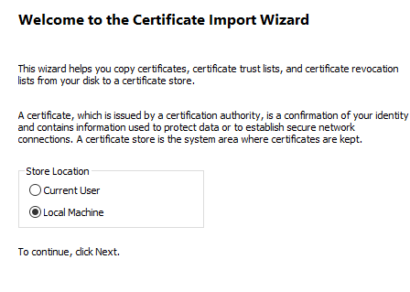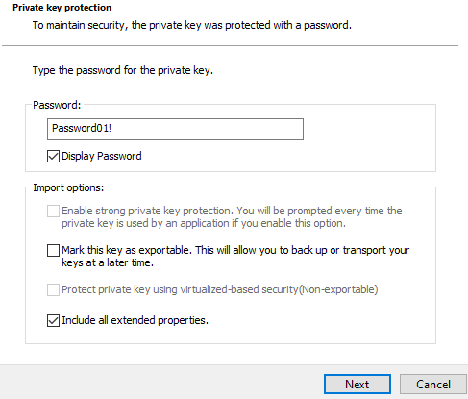

- Run the following commands from an elevated command prompt window to connect azure

$applicationId = "77b7511b-5d98-4309-a3bd-b5395b7d07be"
$thumbPrint = "771bad2c63dd0e45cc8126786a892618bbb7f917"
$TenantId = "72f988bf-86f1-41af-91ab-2d7cd011db47"
Connect-AzureRmAccount -CertificateThumbprint $thumbPrint -ApplicationId $applicationId -TenantId $tenantId

Parameters:
-CertificateThumbprint: Certificate Hash (Thumbprint)
-ApplicationId:SPN
-TenantId: Optional domain name or tenant ID. Domain name will not work in all sign-in situations. For Cloud Solution Provider (CSP) sign-in, tenant ID is required.

- Run the following commands for upload VHD to blob

$vhdName = "<the file name of the VHD file to create on Azure>"
$rgName = "TestSuiteOnAzure"
$urlOfUploadedImageVhd = "https://testsuiteshare.blob.core.windows.net/vhdshare/$vhdName"
Add-AzureRmVhd -ResourceGroupName $rgName -Destination $urlOfUploadedImageVhd -LocalFilePath "<vhdfullPath>" -OverWrite -NumberOfUploaderThreads 32

Parameters:
- ResourceGroupName: Specifies the name of the resource group of the virtual machine.
- Destination: Specifies the URI of a blob in Blob Storage. The parameter supports SAS URI, although patching scenarios destination cannot be an SAS URI.
- LocalFilePath: Specifies the path of the local .vhd file.

- Run the following commands for create azure image based on the VHD

$location = "West US 2"
$rgName = "TestSuiteOnAzure"
$imageName = "<the name of the image to be created on Azure>"
$imageConfig = New-AzureRmImageConfig -Location $location
$imageConfig = Set-AzureRmImageOsDisk -Image $imageConfig -OsType Windows -OsState Generalized -BlobUri $urlOfUploadedImageVhd
New-AzureRmImage -ImageName $imageName -ResourceGroupName $rgName -Image $imageConfig

Parameters:
- ImageName: Specifies the name of an image.
- ResourceGroupName: Specifies the name of a resource group.
- Image: Specifies a local image object.
.

Modify the .csv file
Add or update new record for 20H2 platform in AzureRegression.csv, The ImageID should be new image name. Commit the change and send out a PR to main branch of helper repo.

Run Azure Regression job with pipeline

- Go to the Azure Regression Pipelines with link
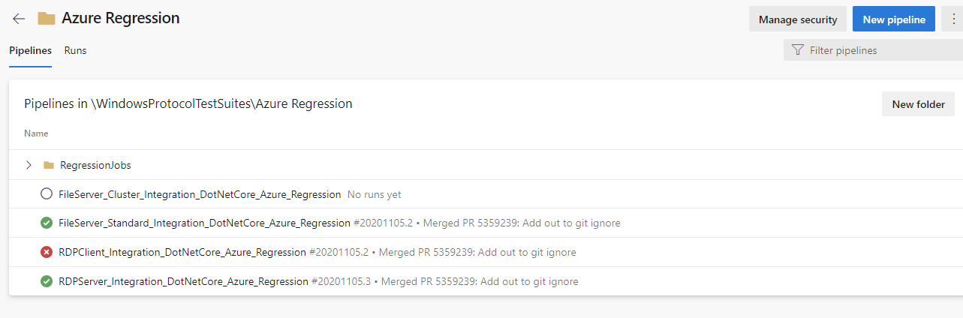
- Go to Integration regression pipeline such as RDPServer_Integration_DotNetCore_Azure_Regression
- Click “Run Pipeline”
- Update the value of “test.helperBranch” to your branch if using private branch
- Click “Run”

